**FACEBOOK AD #2**

**Save Energy**

***Text to use for ad:***

North Star Windows & Doors can help you save money on your energy bills throughout the entire year.

***Image for ad:***

Simply save this image to your desktop by right-clicking the images and selected Save As Picture.

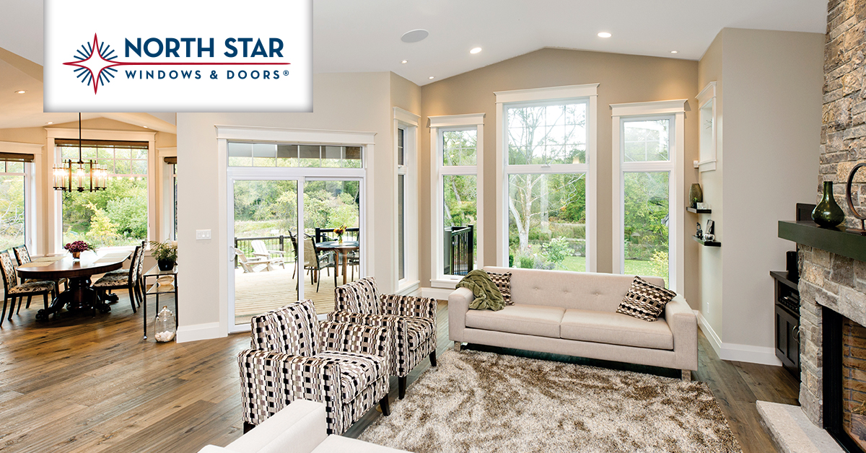

***Helpful Links***

<https://www.facebook.com/business/help/898399293584952?helpref=faq_content#>

<https://www.facebook.com/business/help/132037906870538>

<https://www.facebook.com/business/learn/facebook-create-ad-basics/#>